|  |  |  |
| --- | --- | --- |
|  | **MATHEMATICS METHODS**  **YEAR 12, UNIT 4**  **Semester 2, 2021  Test 4 Weighting 7%**  **[Curriculum references: Logarithms 4.1.1- 4.1.14]** |  |

**Section One: Calculator–free**

|  |
| --- |
| Student Name: _____________________________________ |
| Teacher’s Name: _____________________________________ |

**Time allowed for this section**

Reading time before commencing work: one minute

Working time for paper: forty minutes

Total Marks: forty-six marks

## Materials required/recommended for this section

***To be provided by the supervisor***

This Question/Answer booklet

Formula sheet

***To be provided by the candidate***

Standard items: pens (blue/black preferred), pencils (including coloured), sharpener,  
correction fluid/tape, eraser, ruler, highlighters

Special items: nil

## Important note to candidates

No other items may be taken into the examination room. It is **your** responsibility to ensure that you do not have any unauthorised material. If you have any unauthorised material with you, hand it to the supervisor **before** reading any further.

**Show all working** clearly, in sufficient detail to allow your answers to be checked readily and for marks to be allocated for reasoning. Incorrect answers given without supporting reasoning cannot be allocated any marks. It is recommended that students **do not use a pencil,** except in diagrams

**Question 1. [ 2, 2 = 4 marks]**

Express each of the following as a single logarithm.

a)  b) 

**Question 2. [2, 2 = 4 marks]**

Evaluate each of the following, showing full working.

a)  b) 

**Question 3. [1, 3 = 4 marks]**

If , where x is positive, express each of the following in terms of y.

a)  b) 

**Question 4. [3, 3 = 6 marks]**

|  |  |  |
| --- | --- | --- |
| Give an exact value for $x$ in terms of log10 (simplify your logs) | | |
|  | **b)** |  |

**Question. 5. [1, 1, 1, 2 = 5 marks]**

The function is graphed below. Use the graph to answer the questions that follow.

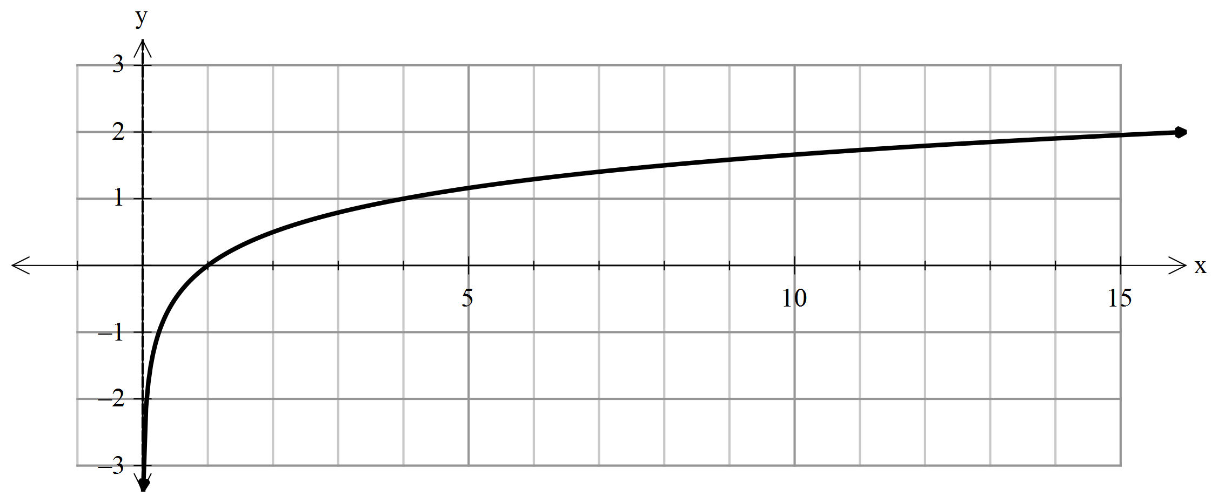

1. Find the value of a.

b) Use the graph to approximate to 1 d.p. the solution to 

c) Approximate the solution for x if 

d) Use the graph to find an approximation to 

**Question. 6 [3 marks]**

Sketch the graph of $y=\log_{2}({x+1)}-2$. Clearly label the key features.

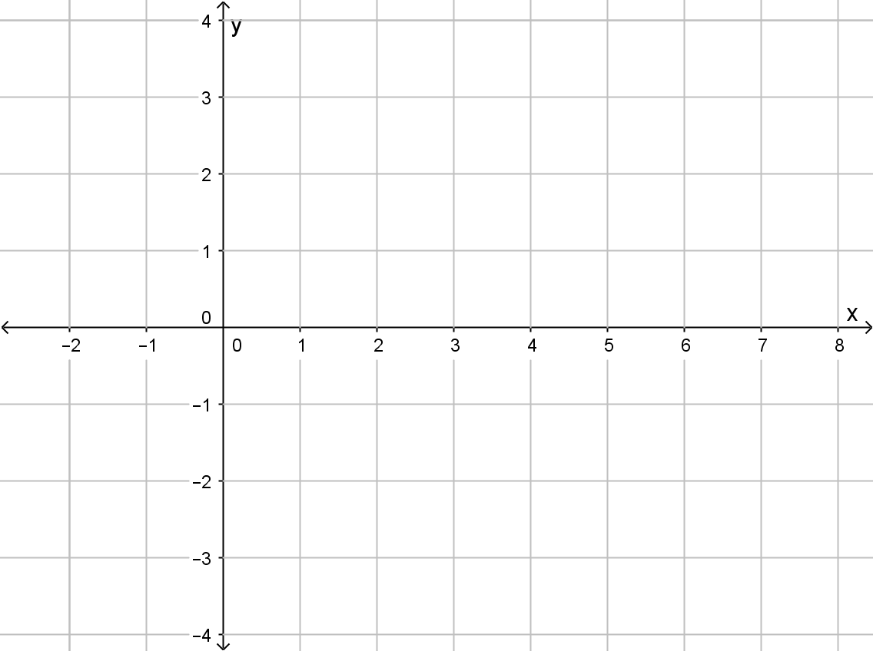

**Question. 7. [3, 3, 3 = 9 marks]**

Differentiate each of the following with respect to x, showing full working.

**(DO NOT SIMPLIFY YOUR ANSWER)**

$If y=x^{2}ln\left(sin x\right) find \frac{dy}{dx}$

1. 
2. 

**Question 8. [ 2, 3 = 5 marks]**

Integrate each of the following, showing full working.

* 1. 
  2. 

**Question 9. [2, 4 = 6 marks]**

Given $y=\frac{lnx}{x}$

a) Find $\frac{dy}{dx}$

b) Hence, or otherwise, use $\frac{dy}{dx}$ to show that 

**End of Calculator Free Section ☺**

**Additional working space.**

|  |  |  |
| --- | --- | --- |
|  | **MATHEMATICS METHODS**  **YEAR 12, UNIT 4: Test 4 2021 Weighting 7%**  **[Curriculum references: Logarithms 4.1.1- 4.1.14]** |  |

**Section Two: Calculator–assumed**

|  |
| --- |
| Student Name: _____________________________________ |
| Teacher’s Name: _____________________________________ |

**Time allowed for this section**

Reading time before commencing work: one minute

Working time for paper: fifteen minutes

Total Marks: eighteen marks

**Material required/recommended for this section**

**To be provided by the supervisor**

This Question/Answer booklet

Formula Sheet (retained from Section One)

**To be provided by the candidate**

Standard items: pens (blue/black preferred), pencils (including coloured), sharpener, correction tape/fluid, erasers, ruler, highlighters

Special Items: drawing instruments, templates, notes on one side of an A4 piece of paper and up to three calculators approved for use in the WACE examinations.

**Important note to candidates**

No other items may be taken into the examination room. It is **your** responsibility to ensure that you do not have any unauthorised notes or other items of a non–personal nature in the examination room. If you have any unauthorised material with you, hand it to the supervisor **before** reading any further.

**Show all your working clearly.** Your working should be in sufficient detail to allow your

answers to be checked readily and for marks to be awarded for reasoning. Incorrect answers given without supporting reasoning cannot be allocated any marks. For any question or part question worth more than two marks, valid working or justification is required to receive full marks. If you repeat an answer to any question, ensure that you cancel the answer you do not wish to have marked.It is recommended that you **do not use pencil**, except in diagrams.

**Question 10. [2, 2, 2, 3 = 9 Marks]**

The annual profit, P **hundred thousand dollars**, of a retail store, is modelled by, $P=2t ln(t)$ for 0 < t < 10, where t is time in years after establishing the store.

1. Find the instantaneous rate of change of profit with respect to time when

t = 1.

b) Find **when** the rate of change of profit, with respect to time, is:

i) $0 per year.

ii) $400 000 per year.

c) Find the largest loss experienced by the store, and when it occurred.

Question 11. [3, 2 = 5 marks]

Synergy, the provider of electricity in Perth, monitors the maximum consumption of electricity over summer measured against the maximum temperatures.

Graphing the data provides us with the following graph, where *C* is maximum consumption in megawatts and *T* is the maximum temperature in degrees Celsius.

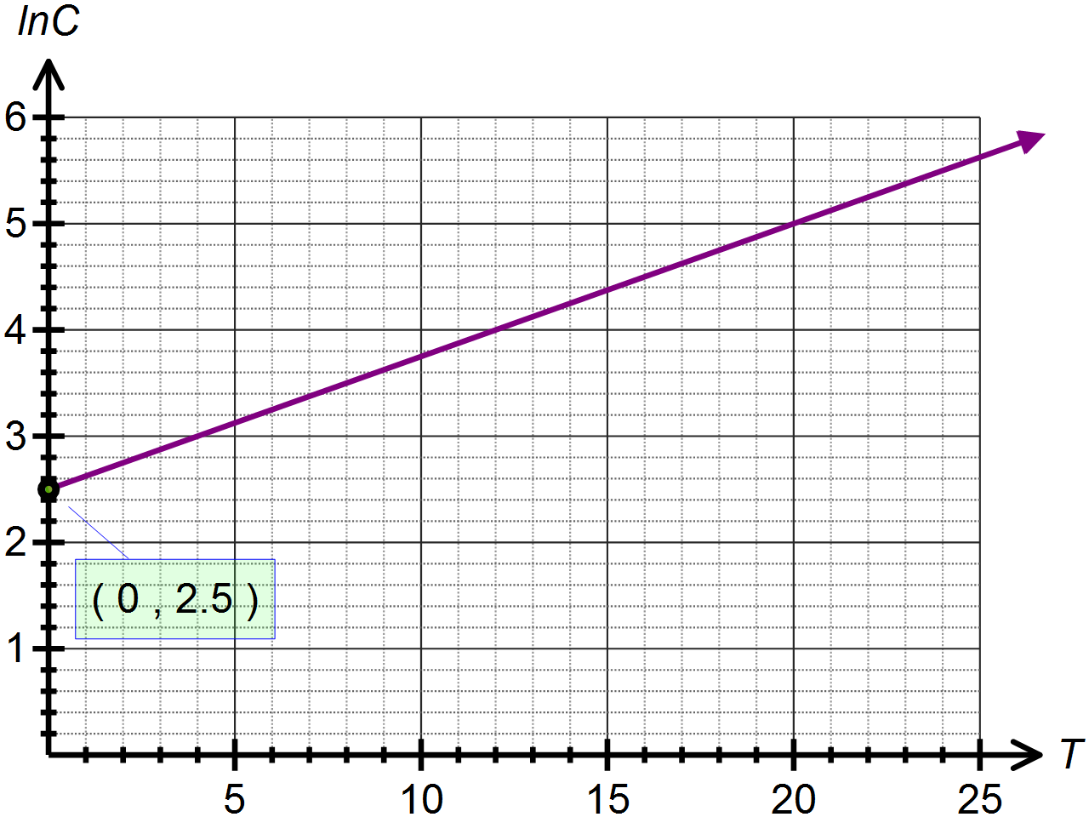

(a) Determine the equation of  in terms of  .

(b) Use your answer to (a) to determine the exponential function which models the energy consumption based on the maximum temperature recorded.

**Question 12. [2, 2 marks]**

 where A and B are constants.

a) Determine the values of A and B.

b) Hence, find 

**The End ☺**

**Additional working space.**